***The Report***

*Section A:*

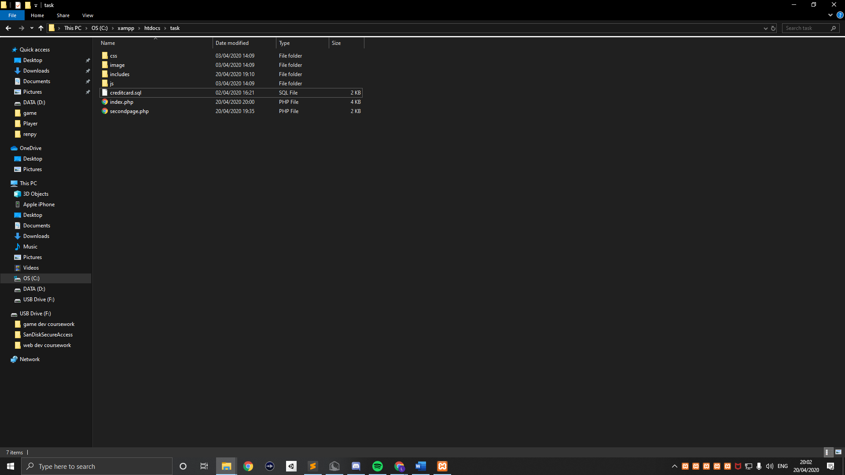

css -> creditcard.css

image -> mastercard.png

includes -> (empty)

js -> creditcard.js

*Section B:*

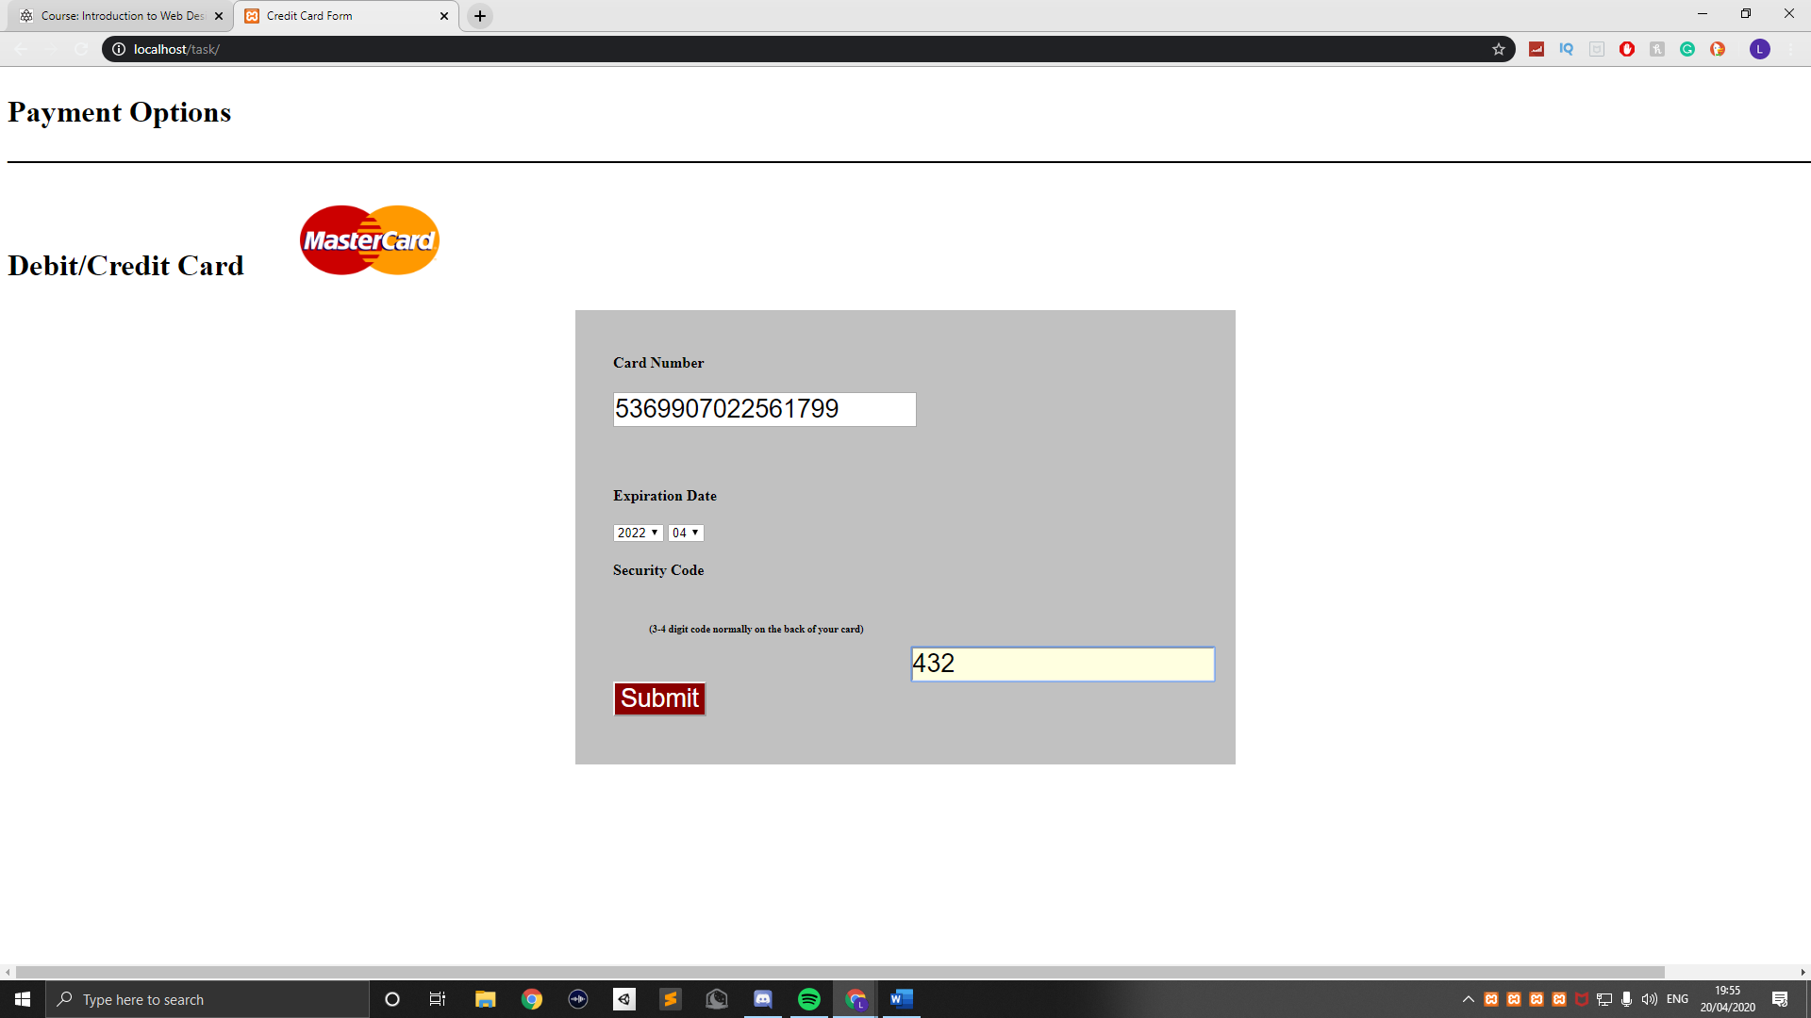

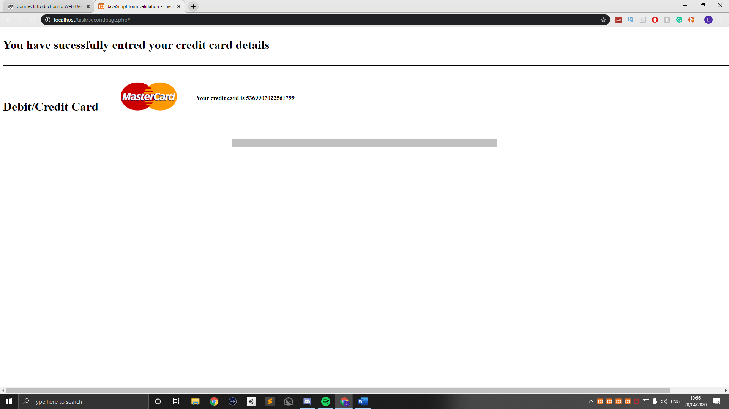

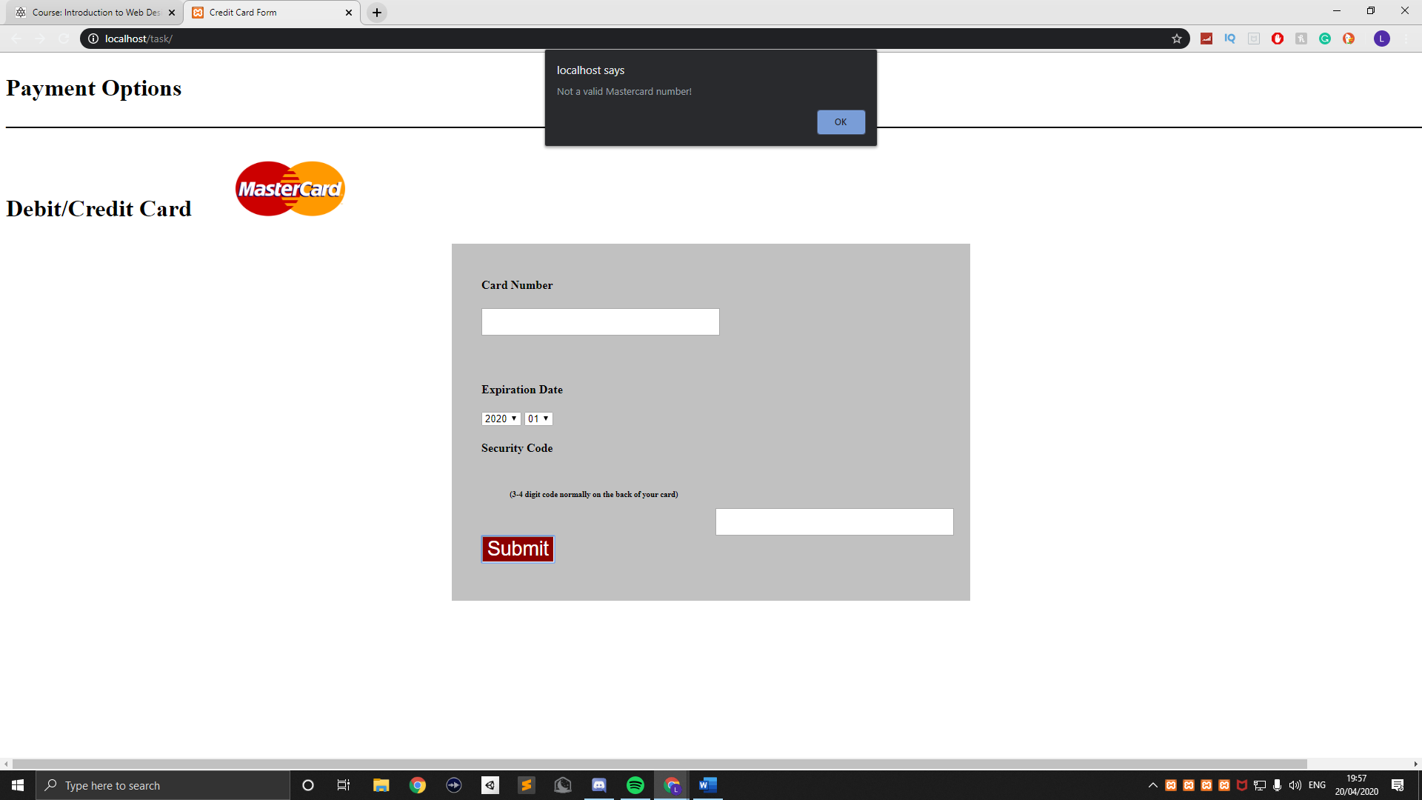

*Section C:*

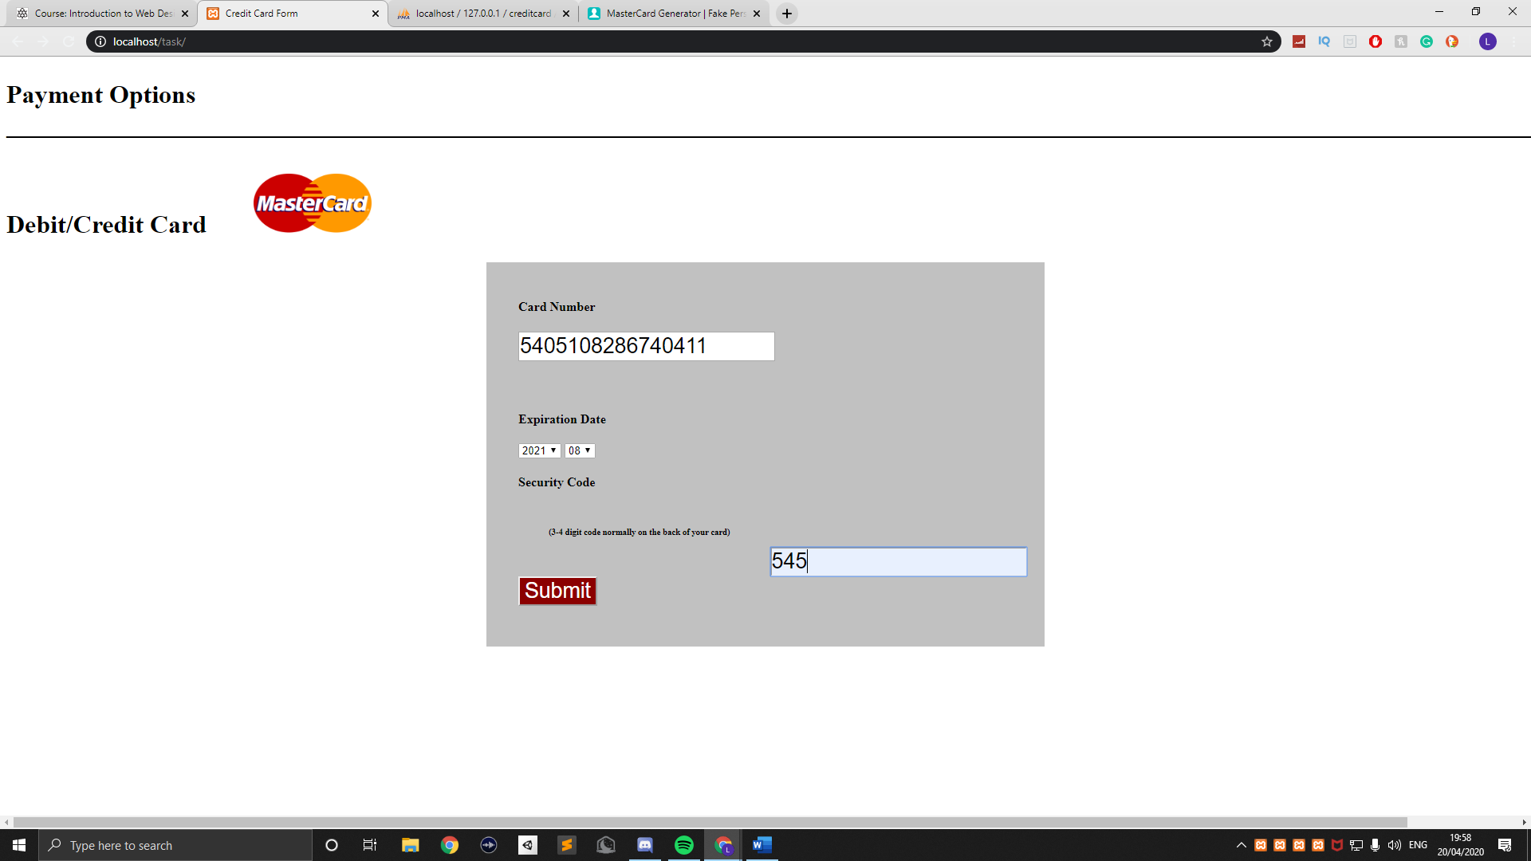

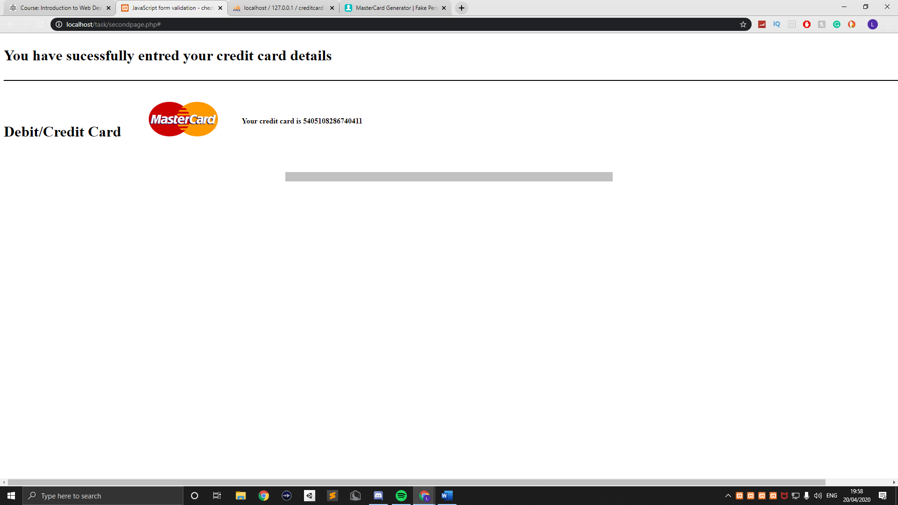

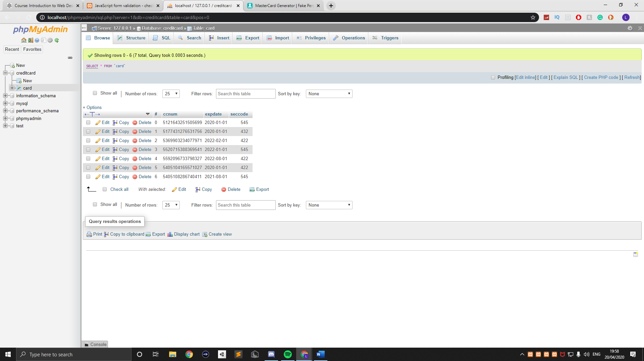

*Section D:*

*creditcard.js*

function cardnumber(inputtxt)

{

var cardno = /^(?:5[1-5][0-9]{14})$/;

if(inputtxt.value.match(cardno))

{

return true;

}

else

{

alert("Not a valid Mastercard number!");

return false;

}

}

*index.php*

<!DOCTYPE html>

<html lang="en">

<head>

<meta charset="utf-8">

<title>Credit Card Form</title>

<link rel='stylesheet' href='css/creditcard.css' type='text/css'/>

</head>

<body onload='document.creditcard.credcard.focus()'>

<div class = "header">

<h1> Payment Options

<br>

_________________________________________________________________________________________________________________________________ </h1>

<h1> Debit/Credit Card <img src="image/mastercard.png" alt="mastercard"></h1>

</div>

<div class="mail">

<form name="creditcard" action="#" method="post">

<ul>

<h4> Card Number </h4>

<li><input type='text' name='credcard'/></li>

<li>&nbsp;</li>

<br>

<h4> Expiration Date </h4>

<select id="Years" name = 'Years'>

<option value="2020">2020</option>

<option value="2021">2021</option>

<option value="2022">2022</option>

</select>

<select id="Months" name = 'Months'>

<option value="01">01</option>

<option value="02">02</option>

<option value="03">03</option>

<option value="04">04</option>

<option value="05">05</option>

<option value="06">06</option>

<option value="07">07</option>

<option value="08">08</option>

<option value="09">09</option>

<option value="10">10</option>

<option value="11">11</option>

<option value="12">12</option>

</select>

<h4> Security Code </h4>

<h6> (3-4 digit code normally on the back of your card) </h6>

<li><input type='text' name='CVV' style="margin-top: 50px; float: left;"></li>

<br>

<li class="submit"> <input type="submit" name="submit" value="Submit" id="ButtonSubmit" style="background-color: darkred; color: white; font-style: bold;"

onclick="cardnumber(document.creditcard.credcard)"

onclick="seccode(document.creditcard.CVV)"

onclick="sortcode(document.creditcard.Months)"

onclick="sortcode(document.creditcard.Years)">

</li>

<li>&nbsp;</li>

</ul>

</form>

</div>

<script src="js/creditcard.js"></script>

</body>

</html>

<?php

$servername = "localhost";

$username = "root";

$password = "";

$dbname = "creditcard";

$connect = mysqli_connect($servername, $username, $password, $dbname);

if (!$connect)

{

die ("connnection failed: " . mysqli_connect_error());

exit();

}

$mysqli = new mysqli("localhost", "root", "", "creditcard");

if ($mysqli->connect_errno) {

echo "Connection failed: ".$mysqli->connect_error;

exit();

}

?>

<?php

if (isset($_POST['submit']))

{

$Years = $_POST['Years'];

$Months= $_POST['Months'];

$expdate = "$Years-$Months-01";

$seccode = $_POST['CVV'];

$cardnumber =$_POST['credcard'];

$sql = mysqli_query($connect, "SELECT * FROM `card` ORDER BY `card`.`#` DESC Limit 1");

if($sql === false)

{

echo "error while executing mysql: " . mysqli_error($connect);

}

else

{

$getdata = mysqli_fetch_row($sql);

$num = $getdata[0] + 1;

$query = "INSERT INTO card VALUES ('$num','$cardnumber','$expdate','$seccode')";

if($connect -> query($query) === TRUE)

{

header("Location: secondpage.php");

exit();

}

else

{

echo "Error";

}

$connect -> close();

}

}

?>

*secondpage.php*

<?php

$servername = "localhost";

$username = "root";

$password = "";

$dbname = "creditcard";

$connect = mysqli_connect($servername, $username, $password, $dbname);

if (!$connect)

{

die ("connnection failed: " . mysqli_connect_error());

exit();

}

$mysqli = new mysqli("localhost", "root", "", "creditcard");

if ($mysqli->connect_errno) {

echo "Connection failed: ".$mysqli->connect_error;

exit();

}

?>

<?php

$sql = mysqli_query($connect, "SELECT * FROM `card` ORDER BY `card`.`#` DESC Limit 1");

$getdata = mysqli_fetch_row($sql);

$num = $getdata[1];

?>

<!DOCTYPE html>

<html lang="en">

<head>

<meta charset="utf-8">

<title>JavaScript form validation - checking non-empty</title>

<link rel='stylesheet' href='css/creditcard.css' type='text/css'/>

<script src="js/creditcard.js"></script>

</head>

<body onload='document.creditcard.cardnumber.focus()'>

<div class = "header">

<h1> You have sucessfully entred your credit card details

<br>

_________________________________________________________________________________________________________________________________ </h1>

<h1> Debit/Credit Card <img src="image/mastercard.png" alt="mastercard"></h1>

</div>

<h4> Your credit card is <?php echo $num ?> </h4>

<div class="mail">

</ul>

</form>

</div>

</body>

</html>

*creditcard.css*

*li {list-style-type: none;*

*font-size: 16pt;*

*}*

*.mail {*

*margin: auto;*

*padding-top: 10px;*

*padding-bottom: 10px;*

*width: 700px;*

*background : #c1c1c1 ;*

*border: 1px soild silver;*

*margin-top: 100px;*

*}*

*.mail h2 {*

*margin-left: 38px;*

*}*

*.header {*

*height: 150px;*

*}*

*.header h3 {*

*float: left;*

*}*

*.mail h4 {*

*float: left;*

*margin-right: 550px;*

*}*

*.mail h6 {*

*float: left;*

*margin-right: 50px;*

*}*

*.mail #Months{*

*float: center;*

*}*

*.mail #Years{*

*float: center;*

*}*

*.mail #CV {*

*float: center;*

*margin-right: 150px;*

*}*

*.mail h6 {*

*margin-left: 38px;*

*}*

*.secondpagemail {*

*margin: auto;*

*padding-top: 10px;*

*padding-bottom: 10px;*

*width: 700px;*

*height: 700px;*

*background : #c1c1c1 ;*

*border: 1px soild silver;*

*margin-top: 100px;*

*}*

*input {*

*font-size: 20pt;*

*}*

*input:focus, textarea:focus{*

*background-color: lightyellow;*

*}*

*input Submit {*

*font-size: 12pt;*

*}*

*.rq {*

*color: #FF0000;*

*font-size: 10pt;*

*}*

*h1 {*

*float: left;*

*}*

*img {*

*width: 150px;*

*height: 75px;*

*margin-right: 50px;*

*margin-left: 50px;*

*}*

*creditcard.sql*

-- phpMyAdmin SQL Dump

-- version 4.8.3

-- https://www.phpmyadmin.net/

--

-- Host: 127.0.0.1

-- Generation Time: Nov 27, 2019 at 11:44 AM

-- Server version: 10.1.36-MariaDB

-- PHP Version: 5.6.38

SET SQL_MODE = "NO_AUTO_VALUE_ON_ZERO";

SET AUTOCOMMIT = 0;

START TRANSACTION;

SET time_zone = "+00:00";

/*!40101 SET @OLD_CHARACTER_SET_CLIENT=@@CHARACTER_SET_CLIENT */;

/*!40101 SET @OLD_CHARACTER_SET_RESULTS=@@CHARACTER_SET_RESULTS */;

/*!40101 SET @OLD_COLLATION_CONNECTION=@@COLLATION_CONNECTION */;

/*!40101 SET NAMES utf8mb4 */;

--

-- Database: `creditcard`

--

-- --------------------------------------------------------

--

-- Table structure for table `card`

--

CREATE TABLE `card` (

`#` int(11) NOT NULL,

`ccnum` varchar(255)NOT NULL,

`expdate` date NOT NULL,

`seccode` int(11) NOT NULL

) ENGINE=InnoDB DEFAULT CHARSET=latin1;

--

-- Dumping data for table `card`

--

INSERT INTO `card` (`#`, `ccnum`, `expdate`, `seccode`) VALUES

(1, 1234567891011123, '2020-06-18', 345);

--

-- Indexes for dumped tables

--

--

-- Indexes for table `card`

--

ALTER TABLE `card`

ADD PRIMARY KEY (`#`);

COMMIT;

/*!40101 SET CHARACTER_SET_CLIENT=@OLD_CHARACTER_SET_CLIENT */;

/*!40101 SET CHARACTER_SET_RESULTS=@OLD_CHARACTER_SET_RESULTS */;

/*!40101 SET COLLATION_CONNECTION=@OLD_COLLATION_CONNECTION */;